**Unit-12:(Introduction to Java Applets)**

**Applet**: Applet cannot be executed independently. Applets can only be executed inside a Java compatible container, such as a browser or **Appletviewer**.

Applets can be embedded in HTML pages and downloaded over the Internet.

Applets code is refreshed automatically each time the user revisits the hosting website. Therefore, keeps full application up to date on each client desktop on which it is running.

**Applet Hierarchy:**

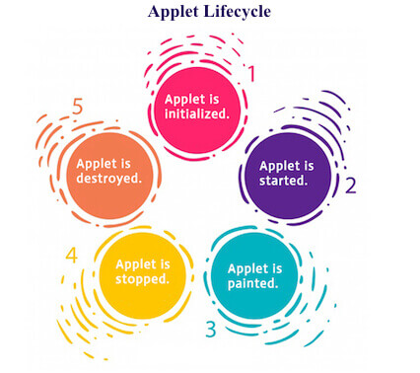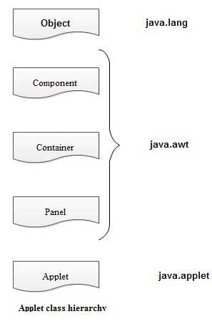

**Lifecycle of Java Applet**

1. Applet is initialized.
2. Applet is started.
3. Applet is painted.
4. Applet is stopped.
5. Applet is destroyed.

For creating any applet **java.applet.Applet** class must be inherited. **It provides 4 life cycle methods of applet.**

* **public void init():** is used to initialized the Applet. It is invoked only once.
* **public void start():** is invoked after the init() method or browser is maximized. It is used to start the Applet.
* **public void stop():** is used to stop the Applet. It is invoked when Applet is stop or browser is minimized.
* **public void destroy():** is used to destroy the Applet. It is invoked only once.

**How to run an Applet?**

There are two ways to run an applet

* By html file.
* By appletViewer tool (for testing purpose).

**Simple Applet Application:**

import java.applet.Applet;

import java.awt.*;

public class FirstApplication extends Applet {

    public void paint(Graphics g){

        g.drawString("welcome",150,150);

        }

}

**Run code using appletviewer:**

**PS E:\JavaExample\IOExample_Sunil> cd src**

**PS E:\JavaExample\IOExample_Sunil\src> javac FirstApplication.java**

**PS E:\JavaExample\IOExample_Sunil\src> appletviewer FirstApplication.java**